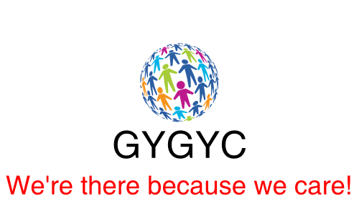

Online Support Service Policy

Great Yarmouth & Gorleston Young Carers

Great Yarmouth and Gorleston Young Carers are now offering their members the opportunity of contacting our team via live streaming. This can be on a one-to-one basis if a young person would like to talk to a Youth Worker and in our Peer Support groups setting.
Live streaming is a valuable way that GYGYC Youth Workers can connect with young people online. We will offer young people access using a service called Zoom (www.zoom.us), for Groups sessions. One to One meeting can be conducted through Zoom or WhatsApp (https://www.whatsapp.com/), Facebook & Messenger, Skype (www.skype.com ),on their own devices and webcams.
All parents/guardians have signed a consent form to enable their young person to be included in the online support service that we offer.
We do talk to young people about online safety before the session starts. We do make sure they understand that live streaming is live and that any comments they make will be seen and heard by others.
We do remind them not to share any personal information and not to respond to contact requests from people they don’t know. We ask young people to be aware of their environment (where they are broadcasting from) and be respectful to other people in their household at the time of the session. GYGYC Staff team will make sure they know who to tell if they see or hear anything upsetting or inappropriate.
In group sessions a minimum of two Youth Workers will lead every online session, with an appropriate maximum number of young people invited to take part. Only young people who have been given consent will be allowed to join the session.
A one-to-one session needs to be requested through Terry, a Youth worker will set up the time and space and contact the young person for the meeting. These sessions may be with one or two Youth Workers who will report any concerns in the normal way in conjunction with our safeguarding policies.
GYGYC will not reproduce or distribute the video chat.
If a young person tells us something that gives us concern for their safety during the group chat, or that they may be in danger, then we will chat to them in a private session about whether other people need to know. In certain circumstances we might need to break their confidentiality if we believe that the young person or another young person is in immediate danger in conjunction with our safeguarding policies.

What we expect from Young People during an online session.
- Treating each other with respect
- Respecting confidentiality
- Welcoming and including new people to the online session
- Being understanding of each other’s differences, and not making assumptions about anyone’s gender identity or sexual orientation
- Not swearing or using violent, bullying, or abusive behaviour/language, nor innuendos
- Not using screen capture during the session or any other method of recording
- To respect each other’s personal space and boundaries.

We will also set group ground rules with the young people during the first session.

This policy will be reviewed on .................................................................

Name ………………………………………………………………………………………………………………………

Signed ………………………………………………………………………………………………………………………

Date ………………………………………………………………………………………………………………………

