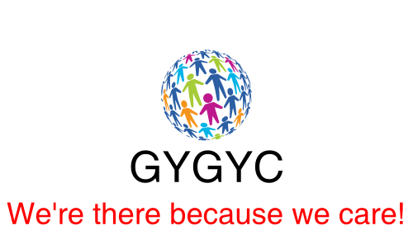

Great Yarmouth & Gorleston Young Carers

Young carer’s agreement

We have a safe and caring meeting place where we can be together and share our feelings and not feel judged.
We have a Young People’s committee that talks with the rest of the group members to ensure the young people’s voices are heard and listened to, which shapes the service we offer to them.
We offer Peer Support Groups and a one-to-one mentoring scheme that gives young carers the opportunity to take part in social activities and new and different adventures they may not normally have access to due to their family life.
We support young carers and their families access different services when they need extra help.
We offer training and life skills to help build young carers confidence, promote positive choices and build resilience.
Our staff team are funny, caring, considerate, approachable, helpful, reliable, positive, understanding, supportive and trustworthy.

Name ……………………………………………………………………………………………………………………………………

Signed ……………………………………………………………………………………………………………………………………

Date ……………………………………………………………………………………………………………………………………

Date of review………………………………………………………………………………………………………………………..

