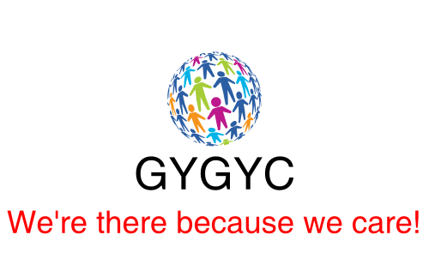

**Programme for January to March 2024 for the Red Group**

**Sessions which will take place fortnightly on a Wednesday 5.30pm to 7.30pm. Food and transport will be provided.**

10th January

24th January

7th February

6th March

20th March

**PLEASE NOTE:**

Transport and food are fully funded by the charity. If your young person cannot attend a session, you need to let us know by 4pm at the latest on the day of the session, if you do not contact us this will be marked as an unauthorised absence. 2 unauthorised absences will lead to their removal from the charity. Attendance is monitored and non-attendance will result in your young person’s place being withdrawn.

Unacceptable behaviour, including bullying and physical contact, will not be tolerated and will result in you being asked to leave the charity.

**ALL** young people are required to wear seatbelts by law and stay seated during journeys. Anyone not conforming to these requirements will result in you being asked to leave the charity.

All our rules are written by, and agreed by, the young people twice a year. We issue strikes to the young people when those rules are broken, when they have reached 3 strikes, they will be asked to leave the charity. When strikes are issued parents/guardian will be informed in writing. At the managers discretion if there is a serious or continuous breach of the rules the young person will be asked to leave even if they have not received any strikes.

**ALL DECISIONS ARE AT THE MANAGERS DISCRETION.**

Funded and supported by

     